**Practice Productively! – Amy Hamilton—NFA Convention 2015**

**Introduction:**

-We not only teach students to play—we teach them to practice!

-Practice is learned over time, and the skills developed go beyond simple imitation.

-Learn to view problems in more *depth*—like a slide in a microscope, higher magnification increases attention to detail—learn to listen for more detail.

-Develop an ever increasing *breadth* of different approaches to solve problems.

-The art of teaching is looking long term—what to introduce today, next week, and next year.

-Training muscles is a slow process and takes place over months and even years.

-A student can think of three concepts at once—add any more and focus becomes diffused.

-Make sure one concept is mastered before more complex concepts are introduced.

-Be meticulous! If you practice something over and over again incorrectly, you practice the problems into the passage and will have to start practicing all over again to correct the problems.

**TONE**

-Is the basis of playing –every note should have a clear, centered tone, which projects and is in tune. These properties must be maintained no matter what the register, dynamic level, speed, or interval between notes.

-Long tones—students must have embouchure and air control to hold a note as long as possible without intonation, quality, or dynamic fluctuation.

-One note should change to the next without interrupting the air stream during note changes. Play any note and have someone else push down the key to change to the next note to show this principle.

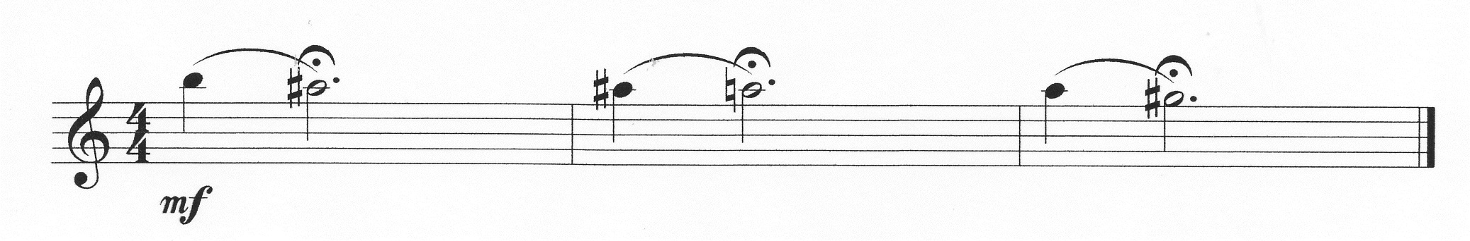

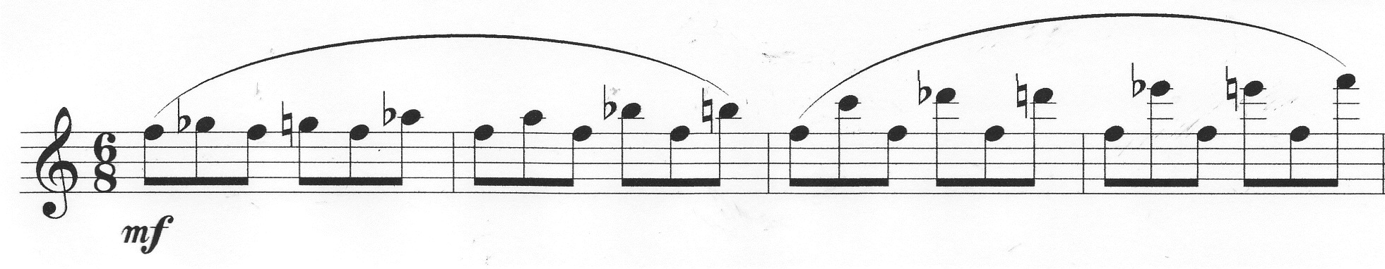Gradually increase size of intervals for legato and flexibility (airplane take-off analogy—air speed increases and embouchure (flaps) change at just the right moment for lift to happen). If the large intervals are difficult initially, focus first on 3rds, then 4ths, etc.

Add exercises to cover the whole range of the instrument to overcome natural tendencies (soft low register and loud high register)

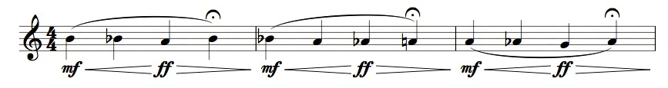 Add dynamic exercises for volume and pitch control. Use metronome quarter=60 and tuner:

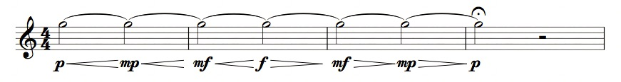

Practice general crescendo-diminuendo long tones in all registers. If intonation is a problem, gradually increase levels. Start mp-mf, then when this is under control without intonation changes, add p-f, etc.

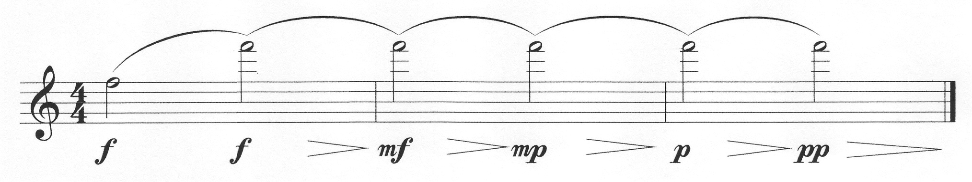Use specific exercises to target difficulties such as upper register flute tapers to niente

**TECHNIQUE**

-Consists of clean finger changes from one note to another so that every note is heard clearly, good tone on each note so every note projects, and impeccable rhythm for tempo and ensemble stability.

-The gold standard of technical practice is starting a passage slowly enough that all three components can be easily addressed at the same time without stress or tension.

-The first, most important aspect of developing effective practice techniques is identifying how slowly you need to take a passage to fully address finger changes, tone, and rhythm, and taking the passage gradually faster at rates that you can maintain consistency in all three.

(repeat 4x)

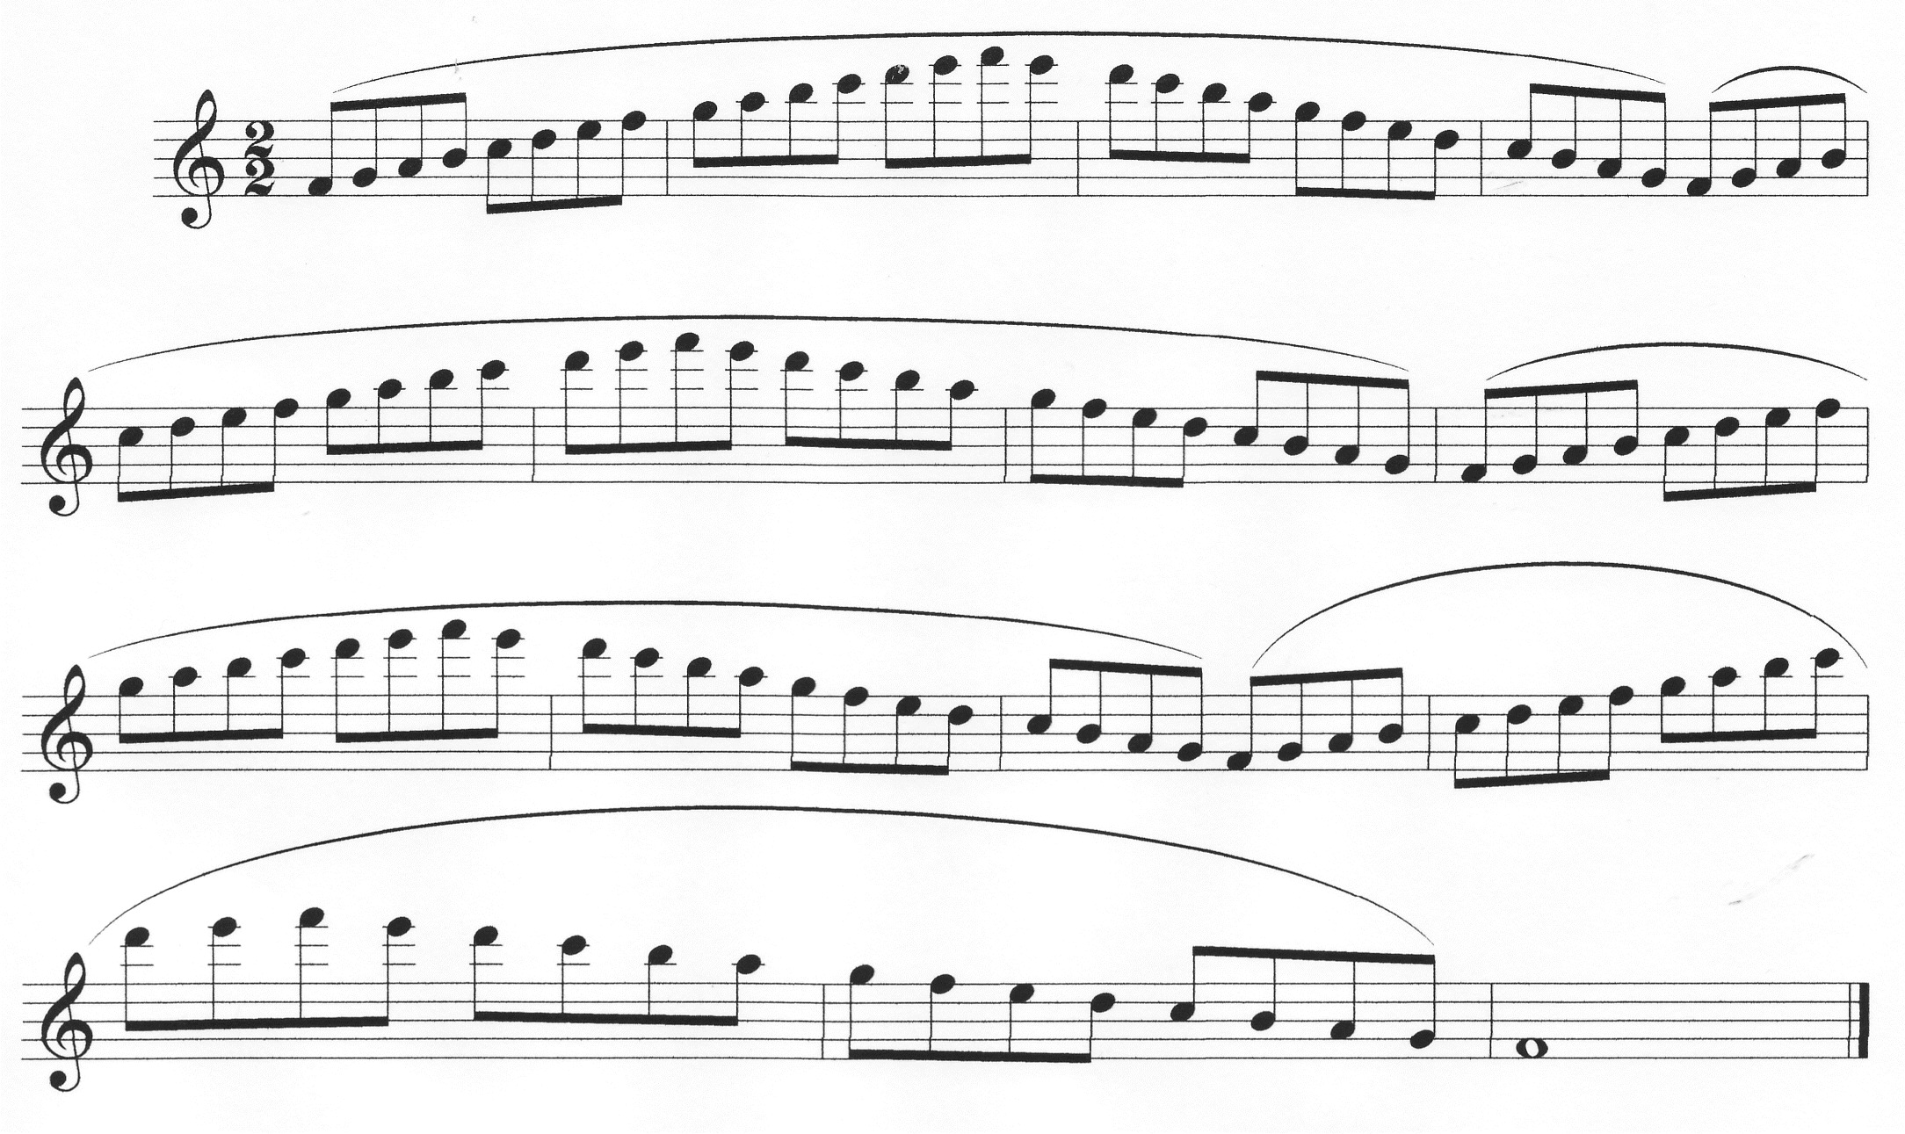

Use the metronome—advance about 2 notches at a time on old school metronomes!

*Tone*

Flute sound is generally weak in the low register, strong in high register. Notice this problem in 2+ octave scales. Correct (by stopping on one lower note at a time if necessary and making that note louder than the preceding note), and keep sound projection even at increasingly higher speeds.

*Finger changes*

1) Timing vs .pressure—adjusting timing will solve problem finger changes—more pressure will make them worse. Exercise—try to raise a finger pushed down with lots of tension, then with just a little. See how little pressure it takes to press down a key with one finger when someone else holds the flute.

2) High fingers vs. fingers close to the keys. Physics dictates that if fingers are at different heights above the keys that they will have a harder time pushing the keys down at the same time.

Practice techniques:

1) identify general area of problem.

2) identify the two notes between which the problem occurs.

3) identify which fingers are too slow or too fast and correct timing.

Problems: As you speed up, you may reach a point where not all components can occur together

1) Stop on problematic notes. The fingering you stop on is secure, and if you add one at a time, all will finger changes will be secure and tone will be even.

2) Play smaller groups at a fast tempo, then connect together. This prevents fingers from getting tense and uneven. It is especially helpful for multiple repetitions of the same group of notes.

*Rhythm*

-Work for control so that all notes are even, and no rushing occurs in scale passages.

-Put metronome on smallest common subdivision for evenness, accuracy, and to prevent rushing.

Important!—when playing with others, especially in unison passages, it becomes immediately obvious if rhythm isn’t exact. For example--imagine a score with three voices playing same 16th passage. Just because your main beats are with the metronome when practicing alone, it doesn’t mean the subdivisions in between the metronome clicks are accurate!

*Other Technical Issues*

*Articulation*-no matter what the tongue style or placement may be, support and open oral cavity must stay the same when slurring and tonguing so sound projection/quality doesn’t suffer. Scale exercises can be practiced slurred then tongued to ensure that the sound quality stays the same. The goal is for tonguing to sound light, not heavy. Thinking longer notes and lighter tongue may help. (double-tonguing—slur scale first, follow with long Ts, long Ks, then alternate long T-K)

*Trills*-Start slow and speed up for evenness and relaxed fingers (eighths-triplets-16ths-16th triplets-32nds)

*Grace notes*—must be as close to beat as possible (piano example--grace notes played on the piano can sound almost simultaneously). Practice without grace notes for even rhythm.

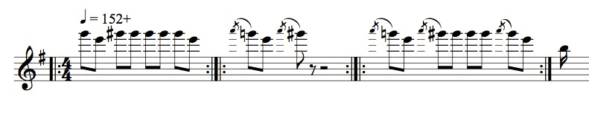

**RHYTHM--**Understand the math! Large square=quarter, small=16ths

Visualize a square subdivided into 4 smaller squares. Then add subdivisions to practice: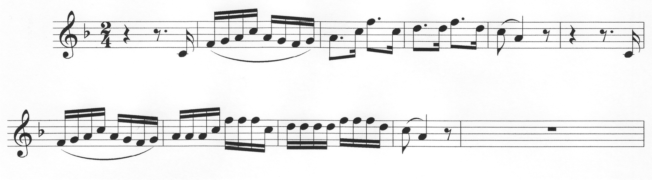

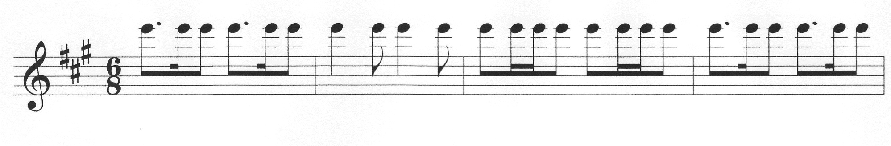Reduce to core rhythm (m. 2) and repeat both measures:

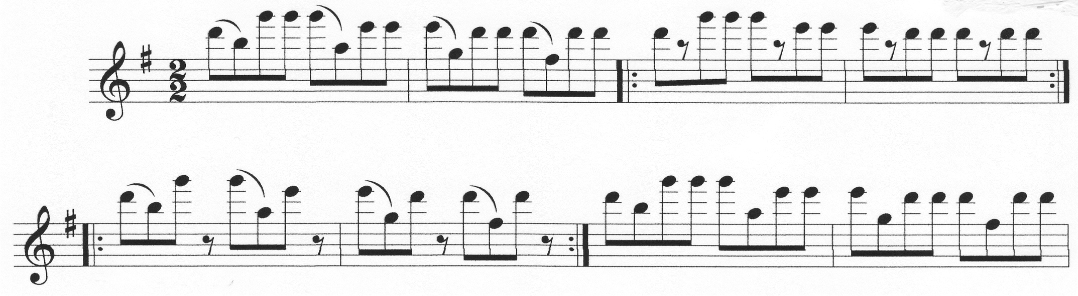Practice with core rhythms to keep passages with wide leaps even:

Take out ties. Add all notes and play constant 16ths. Also, think of shortening tie:

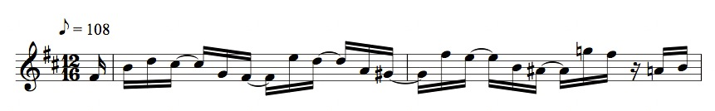

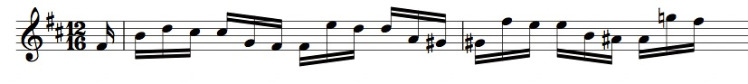

Don’t use breathing to count—breathe well before the 16th rests on the 1st beat—don’t be late!

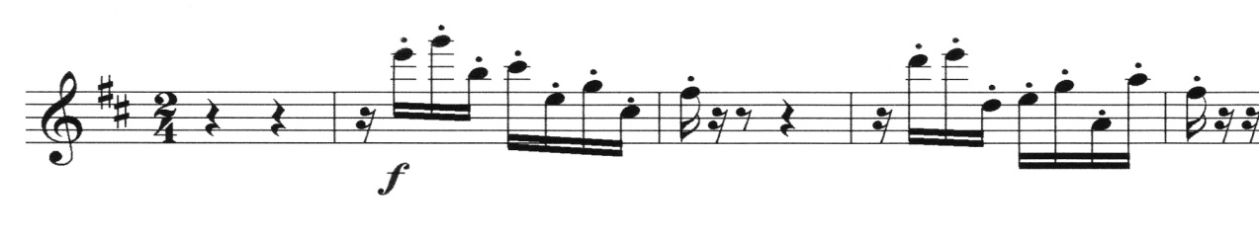

Beware of asymmetrical articulations. Try 2 slurred/2 tongued to increase evenness in m. 2:

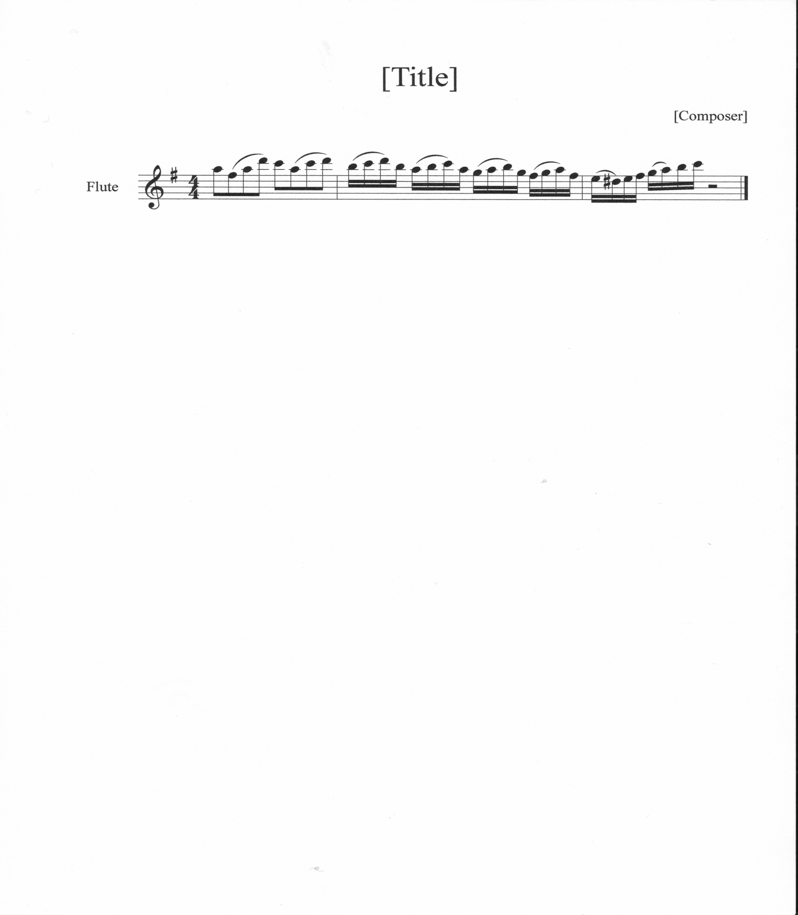

Leave out trills, and play two eighths notes in place of each quarter to feel rhythm: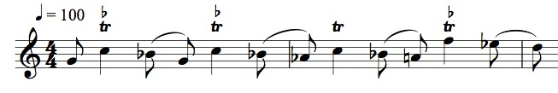

Play with others! Duets help rhythmic consistency. In unison passages, make sure every note moves together in every voice, and develop the ability to identify perfect unison movement.

Play baroque/classical music with accompaniment (even just one line) to feel the integrity of the rhythm!