BEYOND THE NOTES
NFA Online Sunday Series
FALL 2022
Karen North
M. Mus, B.A. (Hons. Mus.), Dip.Ed. Mus.
Email karen@theyoungfluteplayer.com
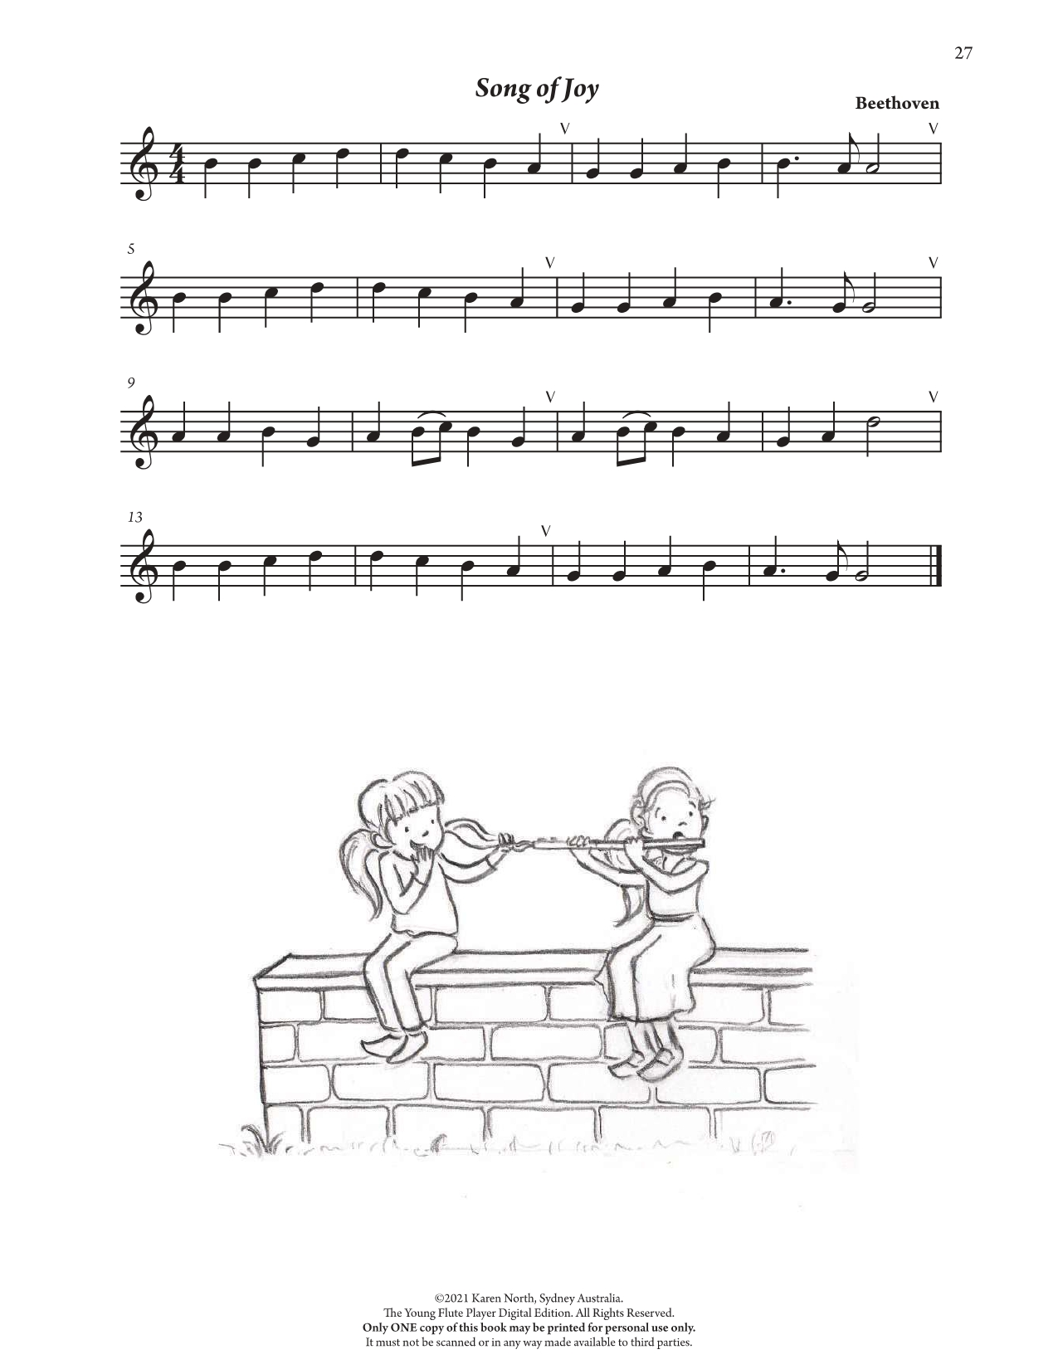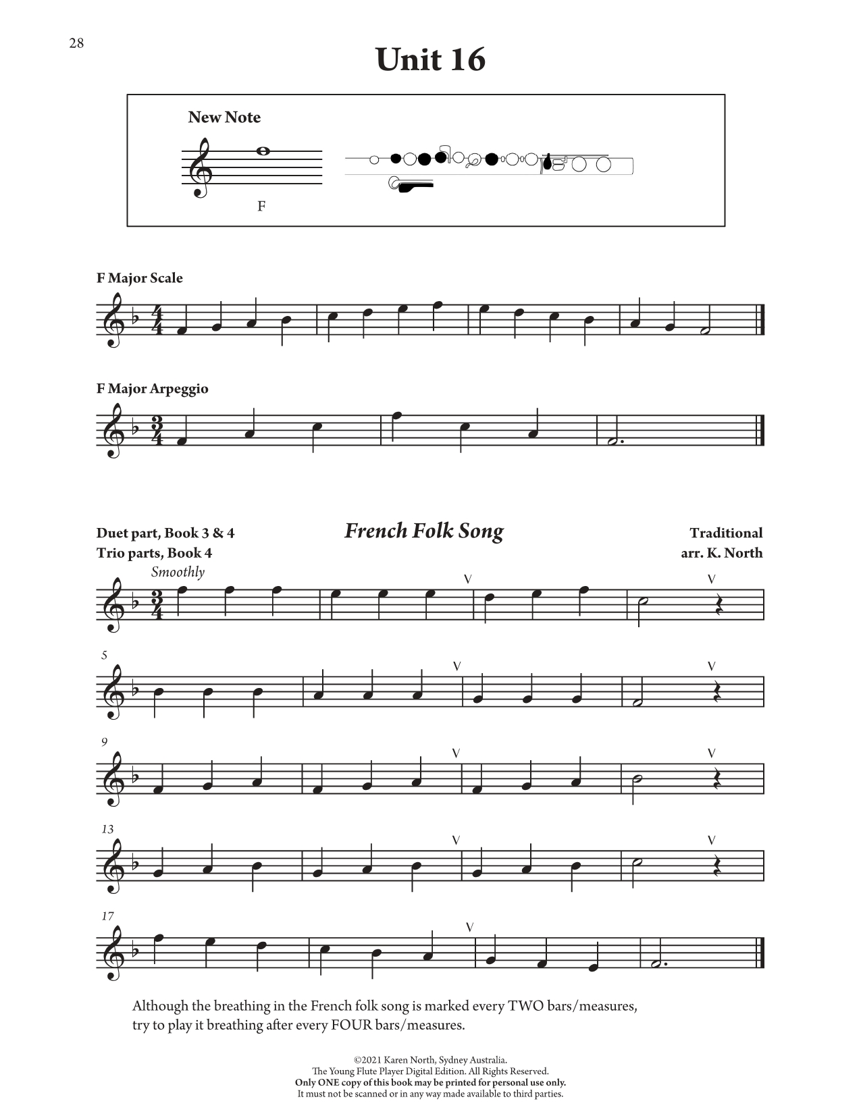
©2021 Karen North, Sydney Australia.
The Young Flute Player Book 1. All Rights Reserved.
Only ONE copy of this work may be printed for personal use only.
It must not be scanned or in any way made available to third parties.

©2021 Karen North, Sydney Australia.
The Young at Heart Flute Player Book 6. All Rights Reserved.
Only ONE copy of this work may be printed for personal use only.
It must not be scanned or in any way made available to third parties.

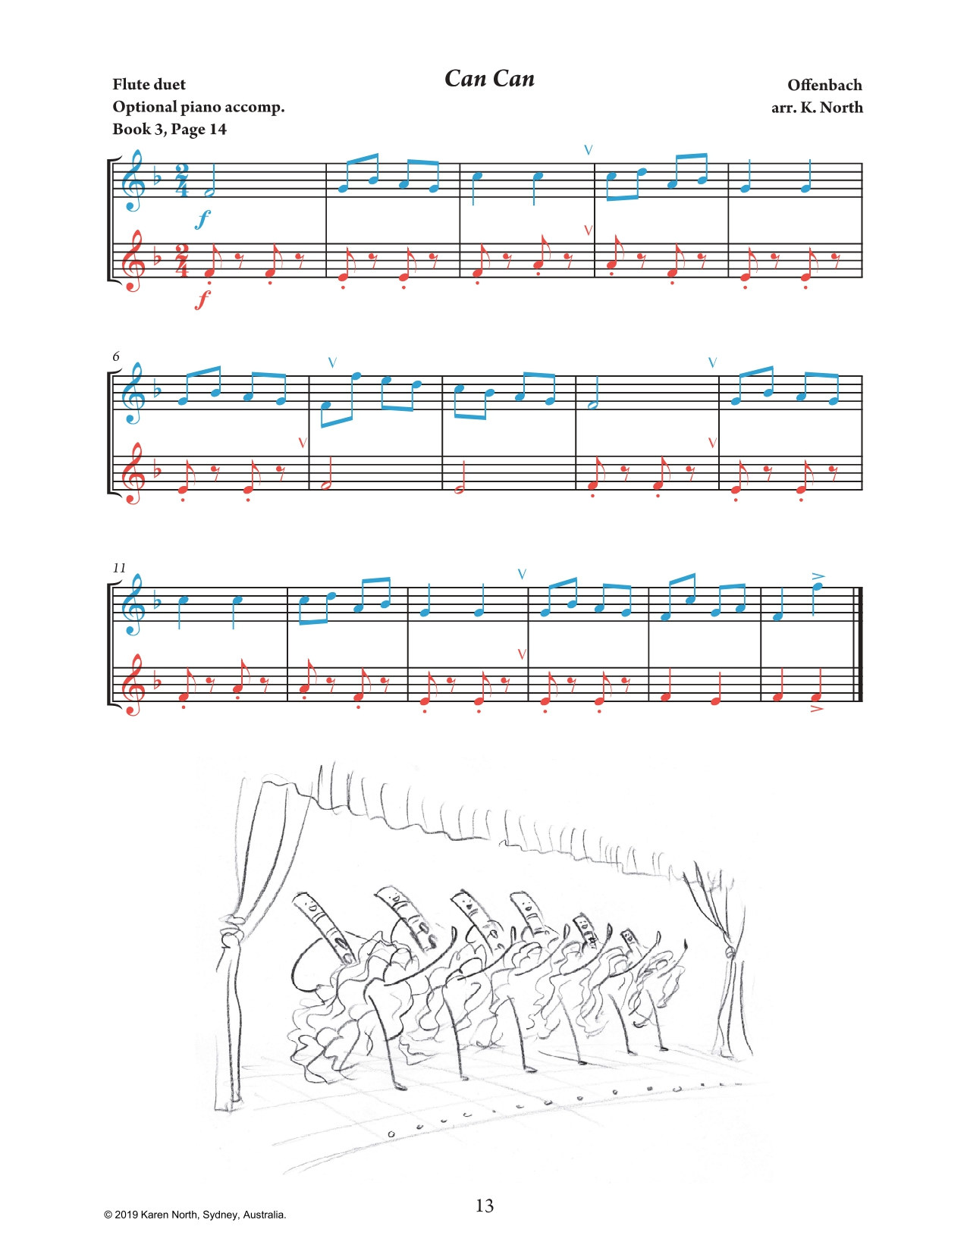
©2021 Karen North, Sydney Australia.
The Young Flute Player Book 4. All Rights Reserved.
Only ONE copy of this work may be printed for personal use only.
It must not be scanned or in any way made available to third parties.

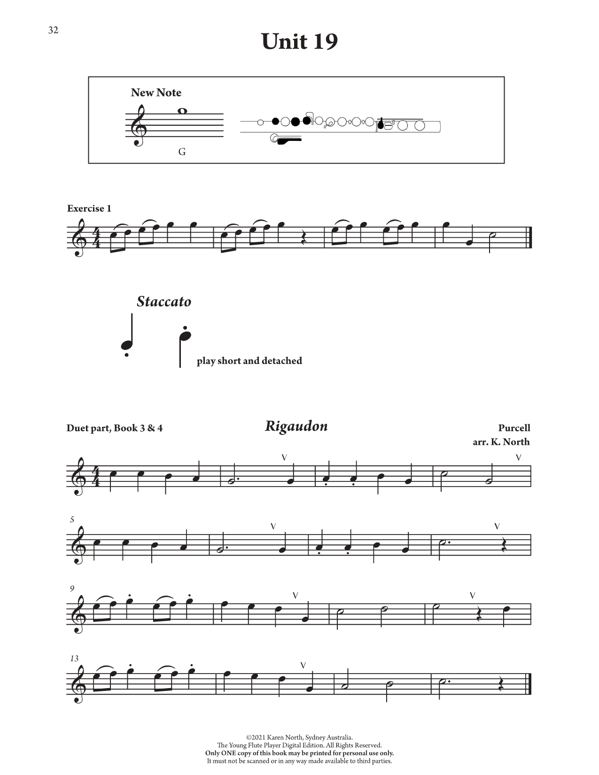
©2021 Karen North, Sydney Australia.
The Young at Heart Flute Player Book 6. All Rights Reserved.
Only ONE copy of this work may be printed for personal use only.
It must not be scanned or in any way made available to third parties.

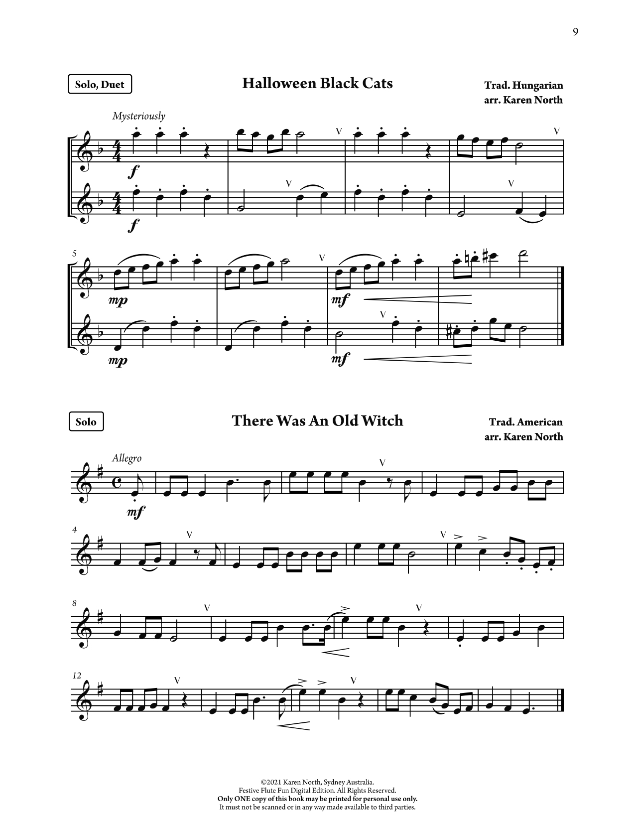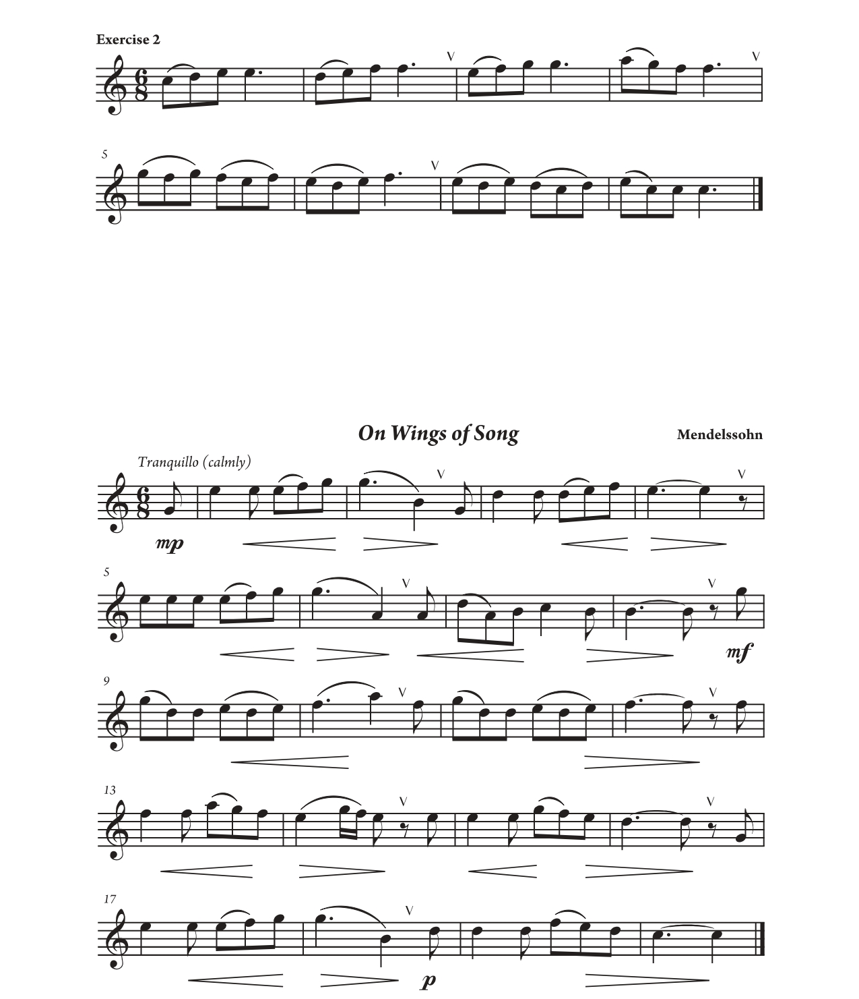
©2021 Karen North, Sydney Australia.
Festive Flute Fun. All Rights Reserved.
Only ONE copy of this work may be printed for personal use only.
It must not be scanned or in any way made available to third parties.

©2021 Karen North, Sydney Australia.
The Young Flute Player Book 2. All Rights Reserved.
Only ONE copy of this work may be printed for personal use only.
It must not be scanned or in any way made available to third parties.

©2021 Karen North, Sydney Australia.
The Young Flute Player Book 5. All Rights Reserved.
Only ONE copy of this work may be printed for personal use only.
It must not be scanned or in any way made available to third parties.

WEBSITE FOR SOURCES: https://www.allegromusicpublishing.com/flutemusic
FURTHER ARTICLES ON TEACHING BEGINNER FLUTE:
- Beginner Flute FAQ https://www.allegromusicpublishing.com/post/beginner-flute-faq
- 5 Essentials for First Flute Lessons https://www.allegromusicpublishing.com/post/5-essentials-for-first-flute-lessons
- B Flat Fingerings https://www.allegromusicpublishing.com/post/to-b-or-not-to-b

